# 01. Motorcycle Showroom

**Environment Specifics**

Please be aware that every JS environment may **behave differently** when executing code. Certain things that work in the browser are not supported in **Node.js**, which is the environment used by **Judge**.

The following actions are **NOT** supported:

* **.forEach()** with **NodeList** (returned by **querySelector()** and **querySelectorAll()**)
* **.forEach()** with **HTMLCollection** (returned by **getElementsByClassName()** and **element.children**)
* Using the **spread-operator** (**...**) to convert a **NodeList** into an array
* **append()** in Judge (use only **appendChild()**)
* **prepend()**
* **replaceWith()**
* **replaceAll()**
* **closest()**
* **FormData()**
* **replaceChildren()**
* Always turn the collection into a **JS array** (forEach, forOf, et.)

If you want to perform these operations, you may use **Array.from()** to first convert the collection into an array.

**Use the provided skeleton to solve this problem.**

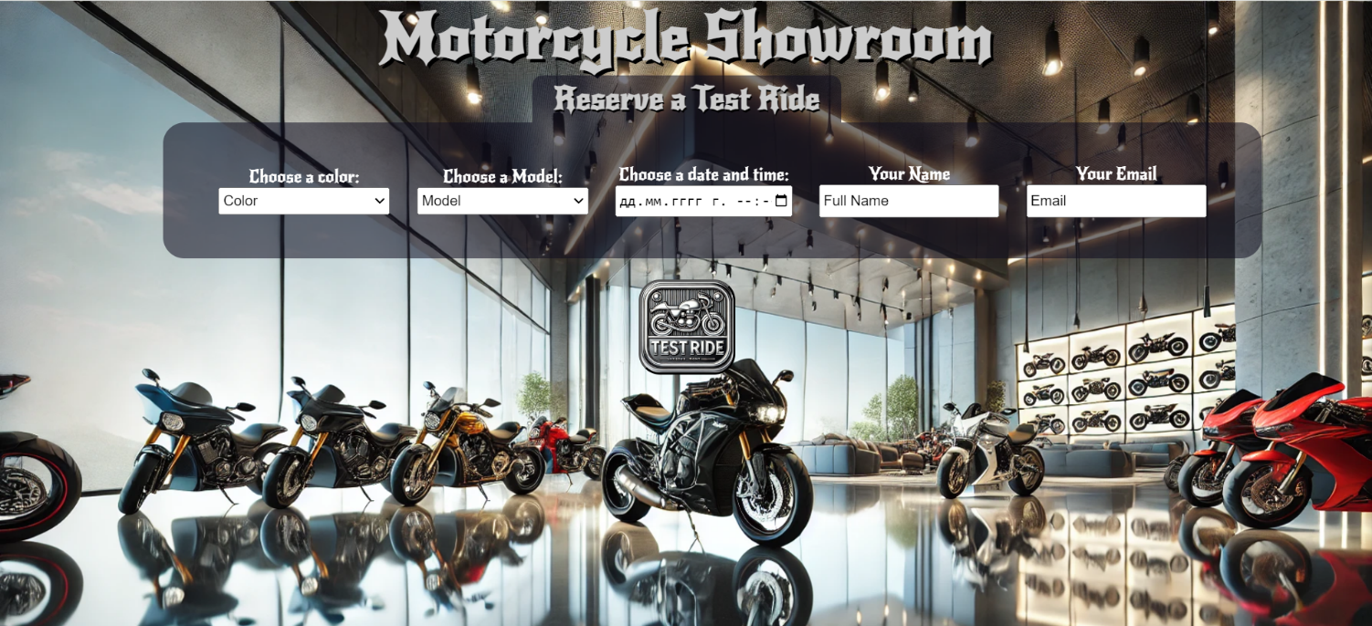**Write the missing functionality** of this user interface. The functionality is divided in the following steps:

**Your Task**

**Write the missing JavaScript code** to make the **Motorcycle Showroom** work as expected:

All fields **(Color, Model, Date and Time, Full Name and Email)** are **filled with the correct input**

* **Color, Model, Full Name, Email,** and **Date and Time** are **non**-**empty** **strings**. If any of them is empty, the program should not do anything.

## 1.Getting the information from the form

• When the **["Test Ride"]** button is clicked, the information from the input fields is listed in the unordered list. A **list item** is added to the **"preview-list"** unordered list.

* The list item should follow the same text format and order as shown in the provided picture.
* When the button is clicked, the **input** fields must be **cleared**, and the **["Test Ride"]** button should be **disabled**. Additionally, the **"Edit"** and **"Next"** buttons need to be added.

The HTML structure looks like this:

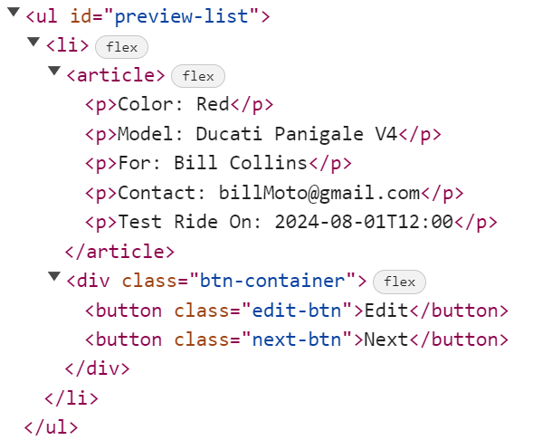

**2.Edit Test Ride Info**

**The functionality here is the following:**

* **When the "**Edit" **button is clicked, all of the information is loaded in to the input fields from step 1 and list item is removed while the** ["**Test Ride**"] **button is enabled again.**

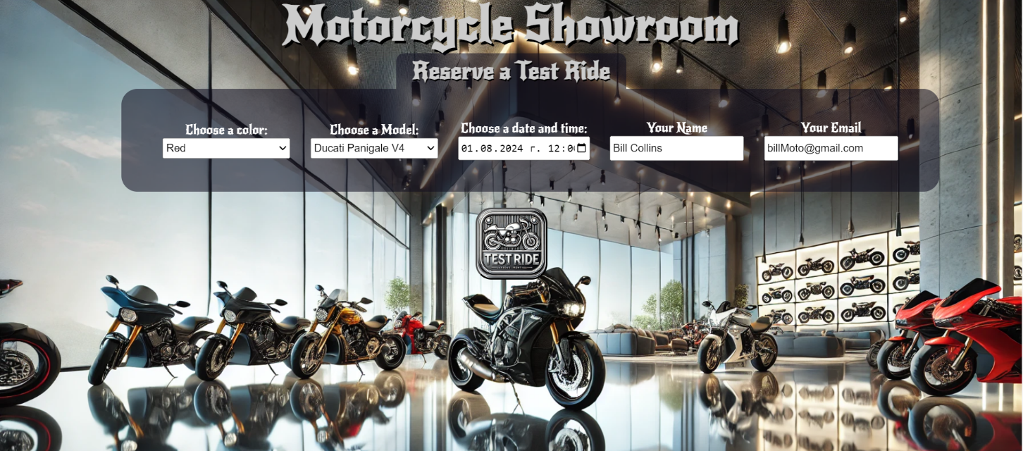

* **The list items must be removed from the** "preview-list"



**3.Next**

* **When the** "Next" **button is clicked,** **the information from** "preview-list" unordered list must be transferred to "complete-list". **For you, this means removing everything inside of the <ul> with class =** "preview-list" **and adding in** "complete-list", **the list item with same information** The "Complete" button must be **added.**

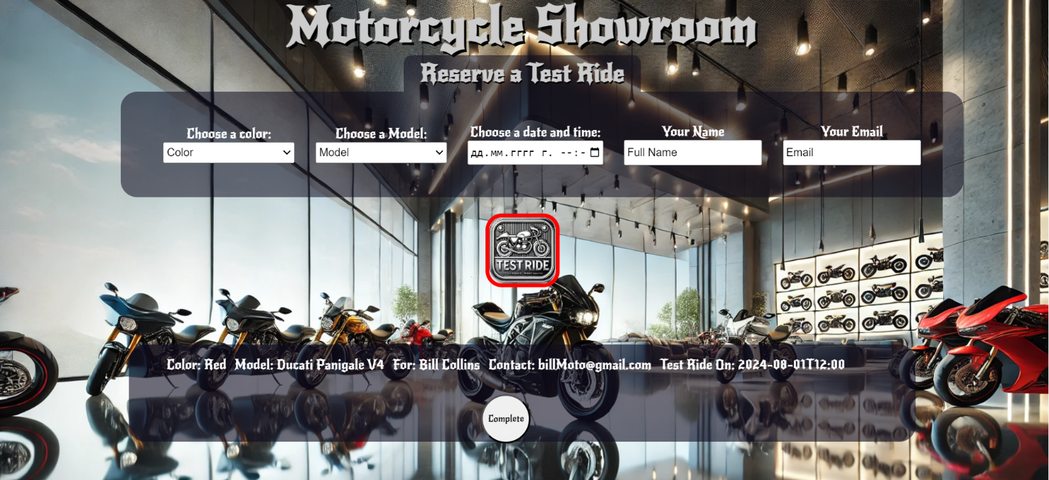

* **This is the HTML** structure **of the** "complete-list" unordered list**:**

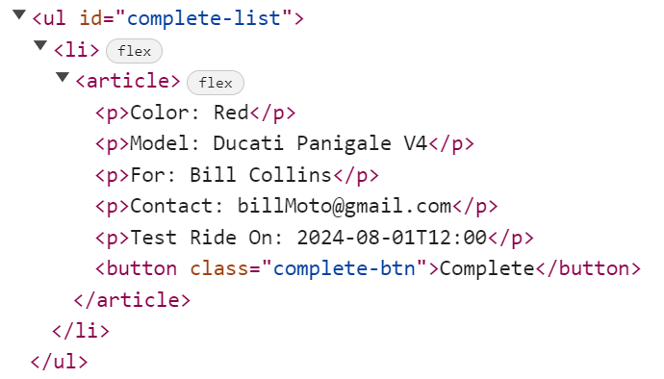

**3.Completing**

* **When the** "Complete" **button is clicked,** you must remove **list item** from **"complete-list"** unordered listand then **add** "**Your Test Ride is Confirmed**" **button**

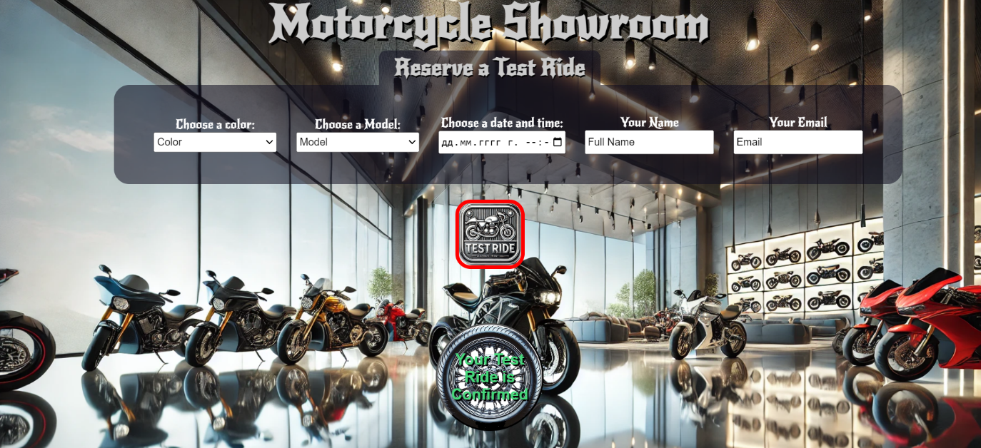

* **This is the HTML** structure**:**

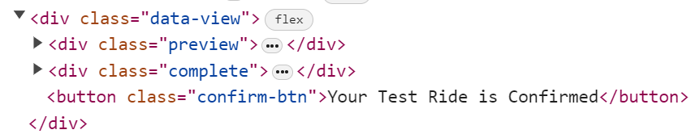

**4.Confirm**

* **When the** "**Your Test Ride is Confirmed**" **button is clicked,** you must **reload** the page.

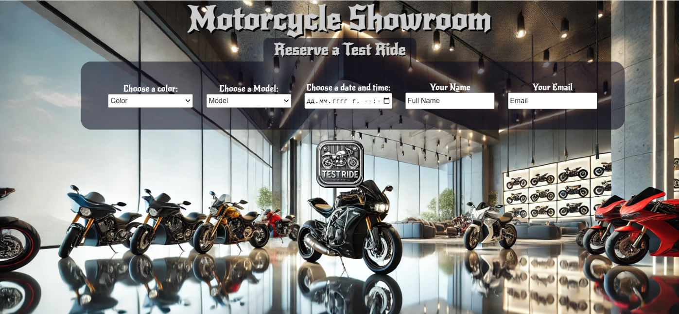

# Submission

Submit only yours **solve()** function.

*GOOD LUCK… ☺*